Columbian Exchange Project – due September 11th!

To examine the impact of the Columbian Exchange, complete the following steps:

* STEP 1 - Pick out your favorite home cooked meal! Your menu must include an appetizer, main dish, two side dishes, and a dessert.
* STEP 2 - Find recipes for ALL of your dishes on your menu (include all sauces, dressings, etc.) You must type up the recipes for each dish. Below each recipe should be a picture of the dish (this can be computer generated or hand drawn).
* STEP 3 - Mark all ingredients as Old World or New World by placing OW or NW next to it.
* STEP 4 - Answer the following question in one – two paragraphs (typed) – WOULD YOUR DINNER HAVE BEEN POSSIBLE WITHOUT THE COLUMBIAN EXCHANGE? WHY OR WHY NOT?
* STEP 5 – Bibliography - Cite your recipes by including the name of the website where your pulled the recipe from (Ex. [www.allrecipes.com](http://www.allrecipes.com))
* STEP 6 - The assignment is due Fri. Sept. 11th! Turn in this assignment sheet with your name on it with the project!

This assignment is worth 100 points! See rubric on the back!

**Old World**

Bananas Olives Wheat

Barley Oranges Turnips

Cabbages Peaches

Chickens Pears

Coffee Pigs

Cows Rice

Lemons Sheep  
Lettuce Sugar

**New World**

Avocados Potatoes

Beans Pumpkins

Bell Peppers Squash

Chocolate Sweet Potato

Chili Peppers Tomato

Corn Turkey

Papayas Vanilla Bean

Peanuts Pineapple

Name: Columbian Exchange Rubric

|  |  |  |  |
| --- | --- | --- | --- |
| **Course** | **Recipe (4 Points)** | **Labeling (Old/New) – (4 Points)** | **Picture (2 Points)** |
| Appetizer |  |  |  |
| **Main Dish** |  |  |  |
| **Side Dish #1** |  |  |  |
| **Side Dish #2** |  |  |  |
| **Dessert** |  |  |  |

## Paragraph/Chart Above Is Filled Out = ______ (30 Points)

|  |  |  |  |  |
| --- | --- | --- | --- | --- |
| **Score/Sill Area** | **6-5 (Excellent)** | **4-3 (Good)** | **2 (Fair)** | **1 (Poor)** |
| Comprehensibility | Can understand all of what is being communicated | Can understand most of what is being communicated | Can understand less than half of what is being communicated | Can understand little of what is being communicated |
| **Organization** | Entry is logical and effective | Entry is generally logical and effective with a few minor problems | Entry is somewhat logical and confusing in places | Entry lacks logical order and organization |
| **Effort** | Exceeds the requirements of the assignment and have put care and effort into the process | Fulfills the requirements of the assignment | Fulfills some of the requirements of the assignment | Fulfills few of the requirements of the assignment |
| **Grammar, Mechanics, Spelling, and Sentence Structure** | Highly polished; no grammar or spelling errors | Polished; maximum of one grammar or spelling error | Adequate; maximum of two grammar or spelling errors | Inadequate discussion; more than two spelling or grammar errors |
| **Content** | Content rich, ideas and explanations are thorough and appropriate | Information and ideas are appropriate but lack full development | Information is limited; ideas are presented but lack cohesion | Information is generalized; ideas and connections are underdeveloped |

**Bibliography = _______ (20 Points) Did you cite all your sources? Y/N**

Columbian Exchange Graph

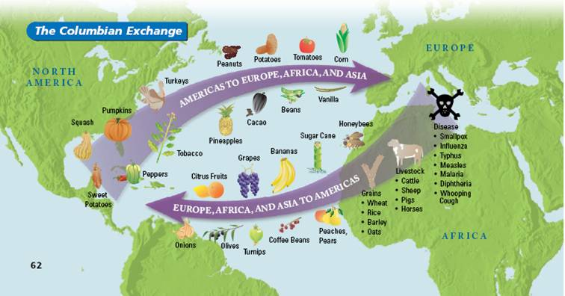 C:\Documents and Settings\chris.bottoms\Local Settings\Temporary Internet Files\Content.IE5\2Y1ZR9L6\MC900030044[1].wmf

The Columbian Exchange had a tremendous impact on both the New World and the Old World. You will research how much of an impact the exchange had. By looking at the devastation of disease, the influx of precious metals to Europe, and the number of missions set up in the new world by the Spanish. You will then create a series of Bar graphs showing the information you collected. Be sure to list your sources at the bottom of each graph.

1. Graph numbers of Native Americans that were killed off by disease after European Arrival (5 pts)
2. Graph the amount of gold that the Europeans pulled out of the New World (5 pts)
3. Graph the amount of Silver that the Europeans pulled out of the New World (5 pts)
4. Graph the number of Missions created by the Spanish in the New World (5 pts)

Be able to give a clear opinion answering the question, which world was better served by the Columbian Exchange, the Old or New?