US/VA History Name: _________________________________
Colonial Review
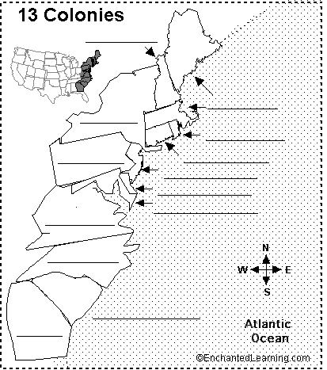
Name the Colonial Region!
(New England, Middle, or
Southern)
- Plantation living
A. ____________________
- Puritan lifestyle
A. ____________________
- Trade as the main economic system
A. ____________________
- Allowed for religious tolerance
A. ____________________
- Directed town meetings
A. ____________________
- Only cared about economic opportunities
A. ____________________
- Ensured the rights of the Englishman
A. ____________________
- What was the middle passage?
__________________________________________________________________________________________________________________________________________________________________________
- __________________________________ was the first permanent English settlement in the New World.
- Describe the importance of the Great Awakening.
__________________________________________________________________________________________________________________________________________________________________________
- What was the first elected body in the New World? ____________________________________
- What name does this elected body go by today? _______________________________________
- These land owners, primarily in Virginia, agreed to be completely loyal to the British throne in exchange for giant land grants. ____________________________________________________
Economies of the Colonies
- List the economic characteristics of the New England Colonies. Explain why each was important.

- List the economic characteristics of the Middle Colonies. Explain why each was important.

- What was the major source of money for the Southern Colonies?

Miscellaneous Questions
- What was the Mayflower Compact and how did it shape the New England colonies’ view of government?
____________________________________________________________________________________________________________________________________________________________________
- How did most people get the opportunity to come to the New World?
__________________________________________________________________________________
- Describe the interactions between Native Americans and Europeans. Remember that there should be 2 different countries that you are mentioning!

